**OUR GOALS FOR STUDENT Achievement 2021-2022 (DRAFT)**

**Reading**

The reading proficiency rate for students who score as "approaches grade level" will increase by 15% for all students on STAAR by focusing on improved Tier 1 instruction.

**Math**

The math proficiency rate for students who score as "approaches grade level" will increase by 10% for all students on STAAR by focusing on targeted instructions using the formative assessment model and data driven instruction.

**Behavior**

The total count of school wide discipline referrals will decrease by approximately 37% through Positive Behavior Interventions & Support (PBIS) practices.

**Attendance**

By June 2021, we will increase our student attendance to a daily average of 97% through student and family engagement.

***Students, Teachers, Parents – Working together for success!***

**4th grade students**

* I will arrive to school on time every day, ready to learn.
* I will follow CHAMPS expectations, PBIS procedures and be held accountable for my actions.
* I will read for twenty minutes a day.
* I will record books I read on my reading log.
* I will complete homework, classroom assignment, and school projects to the best of my ability.
* I will collaborate with my peers and teachers in the academic setting

**In the 4th grade classroom**

* Create a safe and welcoming learning environment for each student.
* Provide quality, engaging, rigorous lessons.
* Provide extra support to those students who are in need.
* Model PBIS and CHAMPS expectations to students.
* Provide incentives to build a positive climate

**AT HOME**

* Reinforce PBIS and CHAMPS expectations at home.
* Review, sign, and return information requested from the teacher/campus.
* Ask your child about their day and inquire about what they have learned.
* Encourage them to challenge themselves in their academic
* Set academic goals with your child and check in on their progress
* Build positive rapport with the school



2021-2022 (DRAFT)

**4TH GRADE**

SCHOOL-PARENT COMPACT

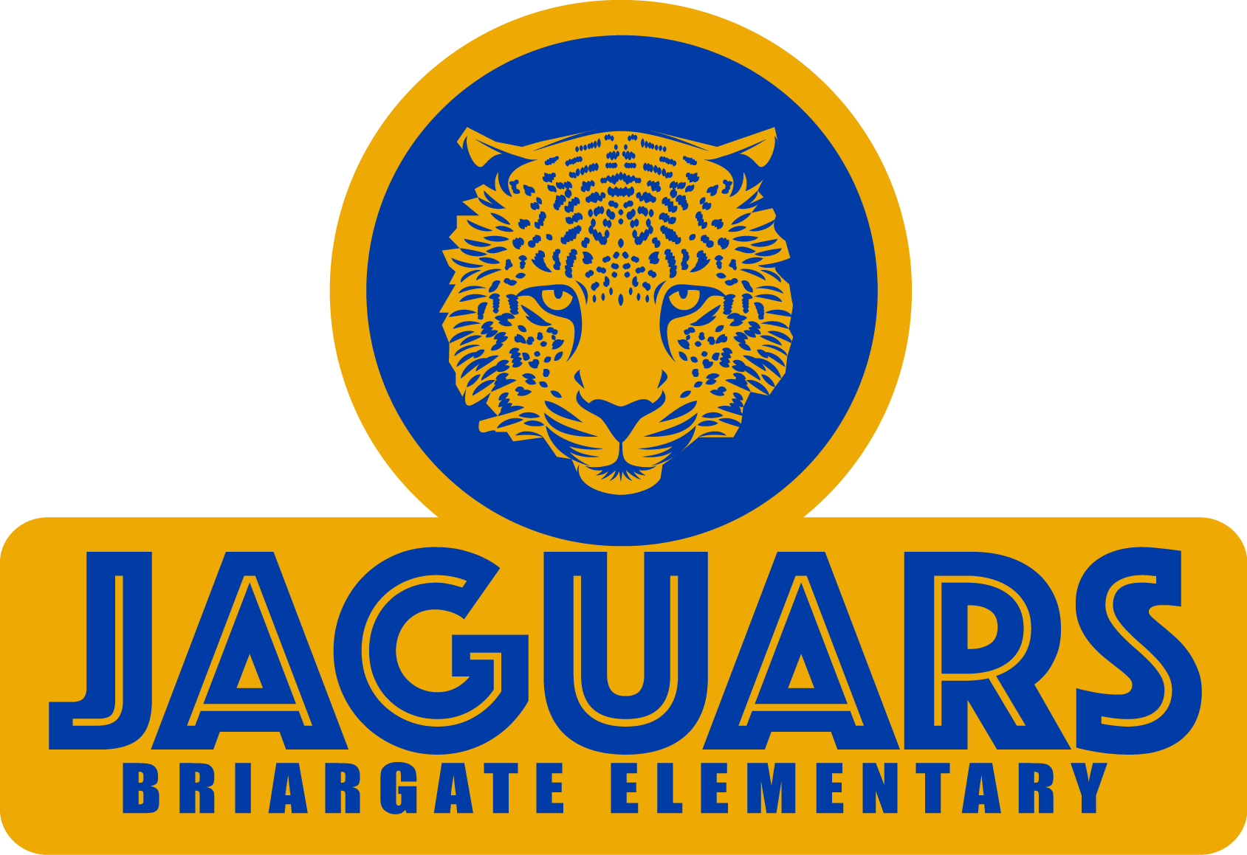

*Be Safe.*

*Be Responsible.*

*Be Respectful.*

**Principal** – Dr. Latoya Garrett

**Assistant Principal** – Kimsheka Bowie

15817 Blue Ridge Rd.

Missouri City, TX 77489

(281) 634-4560

www.fortbendisd.com/bge

**WHAT IS A SCHOOL-PARENT COMPACT?**

Effective schools are a result of families and school staff working together to ensure that children are successful in school. A compact is a voluntary agreement between two groups that firmly unites them. You are invited to be involved in a partnership with Briargate Elementary.

**Jointly DEVELOPED WITH PARENTS**

The parents, students, and staff of Briargate Elementary School will meet yearly to discuss student-learning needs based on current grade-level data. Our School-Parent Compact for Achievement will be revised based on these discussions. Teachers suggest home learning strategies, parents add ideas to make them more specific, and students identify ways to support their learning goals.

*Parents are welcome to contribute comments at any time.*

**Building partnerships**

**Volunteer Information:**

VIPS Coordinator – Sonja Gaskin

[sonia.gaskin@fortbendisd.com](mailto:sonia.gaskin@fortbendisd.com)

**Parent Workshops/Events Information:**

Parent Educator- Charlene Spicer-Harmon

[Charlene.SpicerHarmo@fortbendisd.com](mailto:Charlene.SpicerHarmo@fortbendisd.com) (281) 634-7759

**ACTIVITIES TO BUILD PARTNERSHIPS**

There are many opportunities at our school for parents to volunteer and play a role in their child’s education. Please consider joining the faculty, staff, and fellow parents through some of the following events and programs:

* Open House
* Volunteer for Field Day
* Literacy, Math, and Science Nights
* Special Visitor’s Day such as Donuts with Dads, Muffins with Mom, and Veterans Day
* Parent Workshops: day/night time meetings to increase parent capacity on varied topics
* One Saturday morning event
* At least 2 virtual events

**COMMUNICATION ABOUT LEARNING**

Briargate Elementary is committed to frequent two -way communication with families about children’s learning. Some of the ways you can expect us to reach you are:

• Weekly homework folders

• Current grades available through Skyward/Family Access

• Electronic Marquee will display upcoming school events and school information.

• Progress reports 3 times a year and report cards once per quarter

• Call-Outs and emails regarding school events and school information